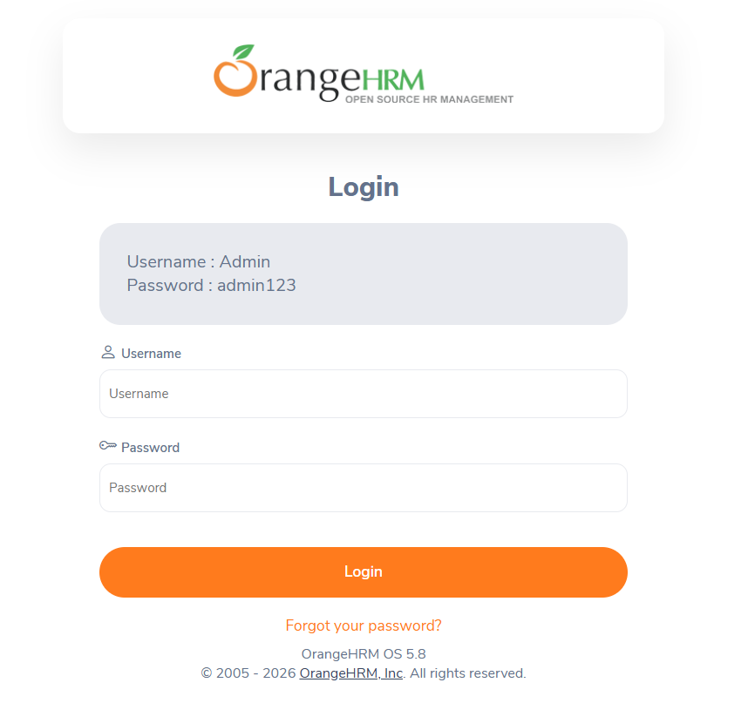

Website Link: Orange HRM
Test Cases: Orange HRM Test Cases

